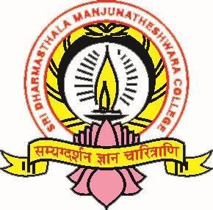



### (Re-Accredited by NAAC at ‘A++’ Grade)

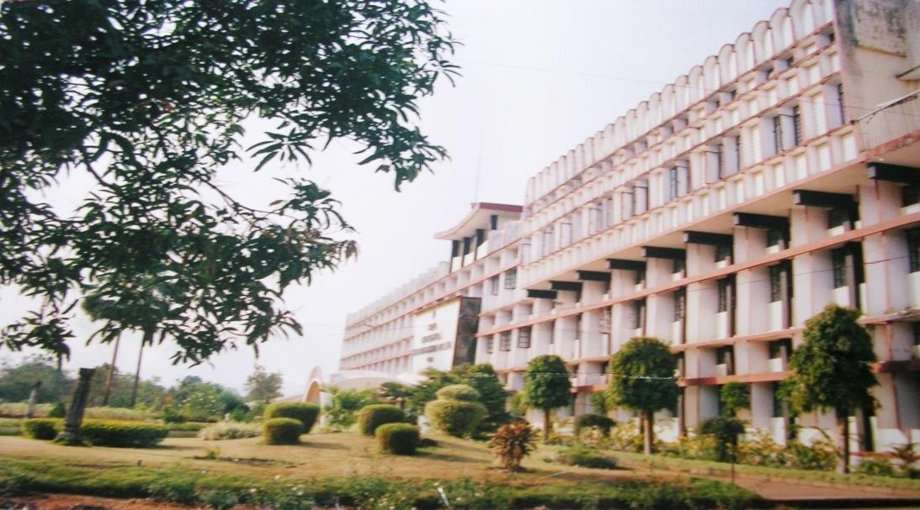

DEPARTMENT OF MATHEMATICS

**SYLLABUS AS PER SEP 2024**

(With effect from 2024-25)





### (Re-Accredited by NAAC at ‘A++’ Grade)

***Syllabus***

**MATHEMATICS**

**(AS PER SEP 2024 GUIDELINES)**

**2024–2025 onwards**

# Approved in BOS meeting on

**31-08-2024**

**Approved in Academics Council meeting held on**

**21-9-2024**

|  |  |  |
| --- | --- | --- |
| **Sl No** | **Particulars** | **Page Number** |
|  | **Preamble** | **4** |
|  | **Programme outcomes** | **4** |
|  | **Progrmme specific outcomes** | **4** |
|  | **Programme structure and course pattern** | **5-6** |
|  | **Guidelines for practicals** | **7** |
|  | **Syllabus structure** | **8** |
|  | **SMACT101 (Paper I)** | **9** |
|  | **Reference Books** | **13** |
|  | **SMACP101(Practical.I)** | **14** |
|  | **SMACT151(Paper II)** | **15** |
|  | **Reference Books** | **18** |
|  | **SMACP151(Practical.II)** | **19** |
|  | **Question Paper Pattern-internal** | **20** |
|  | **Question Paper Pattern-Term end** | **21** |

## Preamble:

The B.Sc. Mathematics course aims to provide students with a comprehensive foundation in mathematical principles, theories, and applications. This program is designed to develop critical thinking, analytical skills, and problem-solving abilities essential for various scientific and technical careers.

The Mathematics syllabus for B.Sc. (Two Major Programme) in use at present was introduced from the academic year 2021-22 as per NEP-2020 structure and guidelines given by the state government in 2021. Based on the directions and guidelines from the Higher Education Council of the Government of Karnataka (GO: ED 166 UNE 2023 Bangalore, Date: 08.05.2024), Mangalore University has issued new guidelines to launch the Three Major B.Sc. degree programme starting from the academic year 2024-25. Consequently, the revised and restructured syllabus for Mathematics as an optional subject in the B.Sc. (Three Major Programme) has been prepared according to the new regulations of the University, by modifying the earlier syllabus, including Lab components and introducing new text and reference books.

The following new syllabus for Mathematics as an optional subject in the B.Sc. (Three Major Programme) has been framed by the Board of Studies in Mathematics for the UG programme in SDM College (Autonomous), Ujire. This syllabus will be implemented starting from the academic year 2024-25.

### Aims and objectives of the restructured syllabus

Equip students with a deep understanding of core mathematical concepts and methodologies.

Improve the perspective of students on mathematics as per modern requirement and develop a spirit of inquiry and scientific temper in the student.

Initiate students to enjoy mathematics, pose and solve meaningful problems, to use abstraction to perceive relationships and structure and to understand the basic structure of mathematics.

Create a student-friendly learning environment by encouraging experimental, problem- solving, and discovery-based approaches to learning mathematics.

To orient students towards relating mathematics applications and improve retention of mathematical concepts in the student.

To enable the teacher to demonstrate, explain and reinforce abstract mathematical ideas by using concrete objects, models, charts, graphs, pictures, posters with the help of FOSS tools on a computer.

Encourage analytical and research-oriented thinking to prepare students for advanced studies and professional careers.

Provide scope for greater involvement of both the mind and the hand and help the student build interest and confidence in learning the subject.

Facilitate an interdisciplinary approach by integrating mathematics with other scientific and technical fields.

Introduce new and relevant textbooks and reference materials to ensure students have access to current knowledge and resources.

**Program Outcomes(PO):**

Programme outcomes (POs) for a Bachelor of Science (B.Sc) describe what students are expected to achieve by the end of their degree programme. Here are some common Programme Outcomes for a B.Sc. degree:

**PO1.** **Knowledge:** Students are able to gain through knowledge in key areas in the subjects offered**.**

**PO2.** **Critical Thinking**: Take informed actions after identifying the assumptions that frame their thinking and actions, checking out the degree to which these assumptions are accurate and valid, and looking at their ideas and decisions (intellectual, organizational, and personal) from different perspectives.

**PO3.** **Effective Communication skills**: Speak, read, write and listen clearly in person and through electronic media in English and in one Indian language, and make sense of the world by connecting people, ideas, books, media and technology.

**PO4.** **Effective Citizenship**: Demonstrate empathetic social concern and equity centered national development, and the ability to act with an informed awareness of issues and participate in civic life through volunteering.

**PO5.** **Ethics**: Recognize different value systems including their own; understand the ethical principles of their decisions and to accept their responsibility.

**PO6.** **Environment and Sustainability**: Understand and exhibit consciousness of the issues of environmental contexts and sustainable development.

**PO7.** **Self-directed and Life-long Learning**: Acquire the ability to engage in independent and life-long learning in the broadest context of socio-technological changes.

**PO8. Problem Solving**: Identify, formulate and analyze complex problems reaching substantiated conclusions using principles of mathematics, pure sciences.

**PO9. Financial Education and investment awareness**: Demonstrate knowledge and understanding of the finance investment awareness and apply these to one’s own work.

**PO10. Individual and team work**: Function effectively as an individual, and as a member or leader in diverse teams, and in multidisciplinary settings.

**PO11. Conduct investigations of complex problems**: Use research-based knowledge and research methods including design of experiments, analysis and interpretation of data to provide valid conclusions.

**PO12. Digital fluency and Cyber Security**: Students will be familiar with digital fluency and aware of cyber security system.

**PO13.** **Employability Skill:** Students will be able to increase their employability through subject knowledge and additional skills.

**PO14.** **Modern tool usage**: Learners are able to create, select add apply appropriate techniques, resources and IT tools in analysis of data within limitations (outcome of final year mini project).

### Program specific outcomes:

1. The syllabus imparts various technical skills solving mathematical problems and applies them to other fields.
2. Student will be acquiring knowledge to compete at national and international level.
3. Employability will be improved with the knowledge of Mathematical software’s.
4. Domain knowledge will be upgraded with the knowledge of applications.
5. Student will be able to handle the challenges due to upgradation of softwares.

This syllabus has been carefully curated by the Board of Studies in Mathematics, incorporating feedback from academic experts, industry professionals, educational policymakers, and all the stakeholders. It is designed to meet the evolving demands of education and industry, ensuring that graduates are well-prepared to contribute effectively in their chosen fields. The implementation of this syllabus will commence from the academic year 2024-25, marking a significant step towards academic excellence and innovation in the field of mathematics.

### COURSE PATTERN AND SCHEME OF EXAMINATION MAJOR SUBJECT: MATHEMATICS

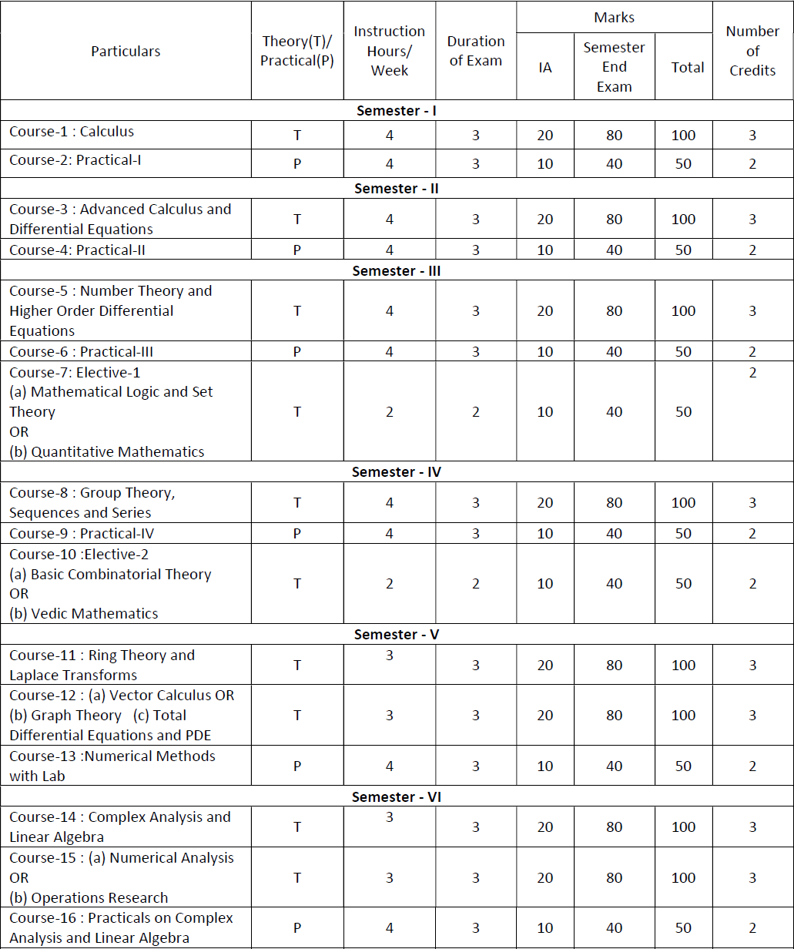

**Note**:

1. In the 3rd and 4th semesters, Course-7(a), Course-7(b), Course-12(a) and Course-12(b) are Elective Courses. Any B.Sc. student with Mathematics as one of their major subjects may choose either Course-7(a) or Course-7(b) in the third semester, and one of Course-10(a) or Course-10(b) in the fourth semester.
2. For 5th and 6th semesters, Course-11 and Course-14 respectively are compulsory Courses. In the 5th semester, a student has to choose one of the special Courses either Course-12(a) or

Course-12 (b). In the 6th semester, a student has to choose one of the special Courses from Course-15(a) or Course-15(b).

# Syllabus

### I Semester

|  |  |  |  |
| --- | --- | --- | --- |
| **Program Name** | B Sc in Mathematics | Semester | I |
| **Course Title** | **Calculas** | | |
| **Course Code** | **SMACT101** | **No. of Credits** | 03 |
| **Contact Hours** | 56 (4 h per week) | **Duration of SEA/ Exam** | 03 hours |
| **Formative Assessment Marks** | 20 | **Summative Assessment Marks** | 80 |

**Course Objectives:**

* To review and strengthen understanding of the fundamental concepts of differentiable functions, including properties of differentiation, and critical points.
* To provide a thorough understanding of key theorems in calculus such as Rolle’s Theorem, Mean Value Theorem, and Cauchy’s Mean Value Theorem.
* To apply calculus concepts to practical problems, including curve sketching, optimization problems, and evaluating integrals using various techniques.
* To develop proficiency in different integration techniques and their applications, including the use of reduction formulae.
* To introduce and explore the concepts of functions of several variables, including limits, continuity, partial derivatives, and their applications.

### Course Outcomes:

* Students will be able to understand and apply properties of differentiation, and solve problems involving local extrema and concavity.
* Students will be able to understand and apply key theorems such as Rolle’s Theorem, Mean Value Theorem, and Cauchy’s Mean Value Theorem in various contexts.
* Students will develop the ability to solve applied optimization problems, sketch curves, and use asymptotes effectively in analysis.
* Students will be able to evaluate definite and indefinite integrals using techniques such as reduction formulae, partial fractions, etc.
* Students will gain a solid understanding of the behavior of functions of several variables, and get ability to compute and interpret directional derivatives and gradients.
* Students will be able to find and classify extreme values and saddle points for functions of two variables, using second derivative tests and other techniques.

|  |  |  |  |  |  |  |  |  |  |  |  |  |  |  |  |
| --- | --- | --- | --- | --- | --- | --- | --- | --- | --- | --- | --- | --- | --- | --- | --- |
| **Course Learning Outcomes (CO)** | | **Program outcomes (POs)** | | | | | | | | | | | | | |
| **At the end of the course students will be able to:** | | **PO 1** | **PO 2** | **PO 3** | **PO 4** | **PO 5** | **PO 6** | **PO 7** | **PO 8** | **PO 9** | **PO 10** | **PO 11** | **PO 12** | **PO 13** | **PO 14** |
| i. | Apply properties of differentiation, and solve problems involving local extrema and concavity. | **√** | **√** |  |  |  |  |  | **√** | **√** |  | **√** | **√** | **√** | **√** |
| ii | Apply key theorems such as Rolle’s theorem, Mean Value theorem, and Cauchy’s Mean Value theorem in various contexts. | **√** | **√** |  |  |  |  |  | **√** |  |  | **√** |  | **√** | **√** |
| iii. | Evaluate definite and indefinite integrals using techniques such as reduction formulae, partial fractions, etc.. | **√** | **√** |  |  |  |  |  | **√** | **√** |  | **√** |  | **√** |  |
| iv. | Understand the behavior of functions of several variables, and get ability to compute and interpret directional derivatives and gradients. | **√** | **√** |  |  |  |  |  | **√** |  |  | **√** | **√** | **√** |  |
| v. | Find and classify extreme values and saddle points for functions of two variables, using second derivative tests and other techniques. | **√** | **√** |  |  |  |  |  | **√** |  |  | **√** |  | **√** |  |
| vi | Identify and apply the concept of level curves and level surface in daily life | **√** | **√** |  |  |  |  |  | **√** |  |  | **√** | **√** | **√** |  |

### Unit I: (14 Hours)

Recapitulation: Definition and Examples of Differentiable functions, Properties of Differentiation, Increasing decreasing functions, critical points, local extrema.

Rolle’s Theorem, The mean value theorem. Concavity, Points of inflection, Second derivative test for concavity, Second derivatives test for local extrema, Asymptotes (horizontal, vertical and oblique), Sketching curves *y* = *f* (*x*), Applied Optimization Problems.

### Unit II (14 Hours)

Indeterminate Forms (all types), L’Hospital’s Rules (First form and stronger form), Cauchy’s Mean Value Theorem, Taylor’s and Maclaurin’s series.

Vector Calculus: Directional Derivatives, Gradient of Functions of Two or Three Variables, Properties of Directional Derivatives, Gradients and Tangents to Level Curves, Level Surfaces, Tangent Planes and Normal Lines to Level Surfaces.

### Unit III (14 Hours)

Integration: Techniques of integration, definite integrals, Mean value theorem for definite integrals, Fundamental theorem of calculus (Part 1 and 2). Derivation of reduction formulae for sin*n xdx*, cos*n xdx*, tan*n xdx*, log*n xdx*, sec*nxdx*, sin*n x* cos*m xdx*, etc. Evaluation of integrals using reduction formulae, Integration of rational functions by partial fractions, trigonometric integrals.

∫ ∫ ∫ ∫ ∫ ∫

### Unit IV (14 Hours)

Functions of several variables: Domain, Range, Interior points, Boundary points, Closed, Open, Bounded and unbounded regions in the plane, Level curves and Level surfaces. Limits and Continuity, Two-Path tests for non-existence of limits, Partial derivatives, Implicit partial differentiation, Partial derivatives and continuity, Higher order partial derivatives, Mixed derivative theorem, Differentiability, Chain rule for differentiation. Extreme value and saddle points for the functions of two variables , second derivative test for local extrema.

### Text Book

Maurice D. Weir, George B. Thomas, Jr., Joel Hass, Frank R. Giordano, *Thomas’ Calculus*, 11th Ed., Pearson, 2008.

# References

* 1. Lipman Bers *Calculus*, Holt,Rinehart & Winston of Canada Ltd., 1969.
  2. Louis Leithold, *Calculus with Analytic Geometry*, 5th Ed., Harper and Row International, 1986.
  3. George B. Thomas and Ross L. Finney, *Calculus and Analytic Geometry*, Addison-Wesley, 1992.
  4. Joseph Edwards, *Integral Calculus for Beginners*, Arihant Publishers, 2016 (original 1896).
  5. Shanti Narayan and P K Mittal, *Differential Calculus*, S Chand and Company Ltd. New Delhi 2014.
  6. Shanti Narayan and P K Mittal, *Integral Calculus* S Chand and Company Ltd. New Delhi 2005.

## Practicals for I Semester

|  |  |  |  |
| --- | --- | --- | --- |
| **Course Title** | Practical -I | | |
| **Course Code** | **SMACP101** | **No. of Credits** | 03 |
| **Contact Hours** | 4 h per week | **Duration of SEA/ Exam** | 03 hours |
| **Formative Assessment Marks** | 10 | **Summative Assessment Marks** | 40 |

### Mathematics practicals with Free and Open Source Software (FOSS) tools for computer programs

**Course Objectives:**

* To learn programming skills in Maxima through listed programs.
* To apply the programming skills in Science and Engineering problems.

### Course Outcomes:

* Students will have the knowledge and skills to implement the programs listed below in the Scilab/Maxima programming language. They can be expected to apply these programming skills of computation in science and Engineering.

### Programs:

1. Finding the limit of a function and checking the continuity of a function at a point.
2. Checking the differentiability of conditional functions.
3. Plotting of standard Cartesian curves using Maxima.
4. Finding the solutions of optimization problems.
5. Verification of Rolle’s theorem and Lagrange’s theorem.
6. Verification of Cauchy’s mean value theorem.
7. Generating Taylor’s series and Maclaurin’s series.
8. Finding the equation of the tangent plane to the surface *z* = *f* (*x, y*) and plot them.
9. Finding the average value and verification of fundamental theorem.
10. Finding the area enclosed between two curves.
11. Find the definite integrals using the reduction formula manually and then verification using maxima command.
12. Finding the partial derivatives and verification of Laplace equation.
13. Euler’s theorem and Illustration examples for its verification.
14. Finding the extreme values of functions of two variables.

Note: The above list may be changed annually with the approval of the BOS in UG (Mathematics).

### II Semester

|  |  |  |  |
| --- | --- | --- | --- |
| **Program Name** | B Sc in Mathematics | Semester | II |
| **Course Title** | **Advanced Calculus and Differential Equations** | | |
| **Course Code** | **SMACT151** | **No. of Credits** | 03 |
| **Contact Hours** | 56 (4 h per week) | **Duration of SEA/ Exam** | 03 hours |
| **Formative Assessment Marks** | 20 | **Summative Assessment Marks** | 80 |

**Course Objectives:**

* To develop a comprehensive understanding of polar coordinates, their applications in graphing, and the analysis of conic sections.
* To gain proficiency in evaluating line integrals and multiple integrals, and understanding their applications in various coordinate systems.
* To provide a solid foundation in differential equations, including methods for solving first- order differential equations.
* To explore practical applications of differential equations in various fields, enhancing problem-solving skills.
* To understand more complex differential equations, including nonlinear equations and orthogonal trajectories, and their solutions.

### Course Outcomes:

* Students will be able to convert between polar and Cartesian coordinates, graph equations in polar coordinates, and calculate areas and lengths.
* Students will classify and analyze conic sections by eccentricity, and work with their polar equations to sketch and identify various conics.
* Students will evaluate line integrals over plane and space curves, understanding their applications and computations.
* Students will master double and triple integrals, including changing between Cartesian and polar coordinates, and apply these techniques to calculate volumes, areas, and averages.
* Students will understand and solve first-order differential equations using various methods, including separation of variables and integrating factors.
* Students will apply differential equations to model and solve real-world problems in physics, chemistry, and other fields.

|  |  |  |  |  |  |  |  |  |  |  |  |  |  |  |  |
| --- | --- | --- | --- | --- | --- | --- | --- | --- | --- | --- | --- | --- | --- | --- | --- |
| **Course Learning Outcomes (CO)** | | **Program outcomes (POs)** | | | | | | | | | | | | | |
| **At the end of the course students will be able to:** | | **PO 1** | **PO 2** | **PO 3** | **PO 4** | **PO 5** | **PO 6** | **PO 7** | **PO 8** | **PO 9** | **PO 10** | **PO 11** | **PO 12** | **PO 13** | **PO 14** |
| i. | Relate polar and Cartesian coordinates, graph equations in polar coordinates, and calculate area, volume, and lengths. | **√** | **√** |  |  |  |  |  | **√** |  |  | **√** | **√** | **√** |  |
| ii | Classify and analyze conic sections by eccentricity, and work with their polar equations to sketch and identify various conics. | **√** | **√** |  |  |  |  |  | **√** | **√** |  | **√** | **√** | **√** |  |
| iii. | Evaluate line integrals over plane and space curves, understanding their applications and computations. | **√** | **√** |  |  |  |  |  | **√** |  |  | **√** | **√** | **√** |  |
| iv. | Double and triple integrals, including changing between Cartesian and polar coordinates, and apply these techniques to calculate volumes, areas, and averages. | **√** | **√** |  |  |  |  |  | **√** |  |  | **√** | **√** | **√** |  |
| v. | Understand and solve first-order differential equations using various methods, including separation of variables and integrating factors. | **√** | **√** |  |  |  |  |  | **√** | **√** |  | **√** | **√** | **√** | **√** |
| vi | Apply differential equations to model and solve real-world problems in physics, chemistry, and other fields. | **√** | **√** |  |  |  |  |  | **√** | **√** |  | **√** | **√** | **√** | **√** |

### Unit I: (14 Hours)

Polar Co-ordinates: Definition, Polar equations and graphs, Relating Polar and Cartesian Co-ordinates, Graphing in Polar Co-ordinates, Areas and Lengths in Polar Co-ordinates, Area of a surface of revolution.

Conic Sections: Classifying conic sections by eccentricity, Conic Sections in Polar Co-ordinates, Polar equation for lines, ellipse, parabola and hyperbola with eccentricity. Identification by finding eccentricity, and drawing the sketch .

### Unit II: (14 Hours)

Line Integrals: Definition and Examples, Evaluating line integrals over plane curves and over space curves.

Multiple Integrals : Double Integrals over rectangles, Double integrals as volumes, Fubinis theorem for calculating double Integrals, Finding regions of Integration, Double integrals over bounded Nonrectangular regions, Volume of solids, Evaluating the double integrals, Finding regions, Reversing the order, Areas of bounded regions in the plane, Average, Volume of an integrable function, Evaluating double integrals in Polar co-ordinates, Finding limits of function, Area in Polar co-ordinates. Changing Cartesian Integral to Polar Co-ordinates, Triple integrals in Rectangular co-ordinates, Evaluating triple integrals.

### Unit III: (14 Hours)

Recapitulation: Definitions, Families of Curves, Examples of Differential Equations, Definitions, Families of solutions, Equations of Order One, Separation of Variables.

Equations with Homogeneous Coefficient, Exact Equations, The Linear Equation of Order One, The General Solution of a Linear Equation, Integrating factors found by inspection, The Determination of Integrating Factors, Substitution Suggested by the Equation, Bernoulli’s Equations.

### Unit IV: (14 Hours)

Applications of Differential Equations : Elementary Applications Velocity of Escape from the Earth, Newton’s law of Cooling, Simple Chemical Conversion Logistic Growth and the Price of Commodities.

Orthogonal Trajectories : Cartesian and Polar co-ordinates.

Nonlinear Equations, Factoring the Left Member, Singular Solutions, Eliminating the Dependent Variable, Clairaut’s Equation, Dependent Variable Missing, Independent Variable Missing.

### Text Book

* 1. Maurice D. Weir, George B. Thomas, Jr., Joel Hass, Frank R. Giordano, *Thomas’ Calculus*, 11th Ed., Pearson, 2008 (for Unit-I and Unit-II).
  2. Earl D Rainville and Philip E Bedient, *Elementary Differential Equations*, Pearson, 8th Ed., 2016. (For Unit III and Unit-IV.)
  3. Narayanan and Manicavachagom Pillay, *Differential Equations*, Viswanathan (Printers and Publisher) PVT Ltd., 1991. (For Unit-IV.)

# References

1. Maurice D. Weir, George B. Thomas, Jr., Joel Hass, Frank R. Giordano, *Thomas’ Calculus*, 11th Ed., Pearson, 2008.
2. Louis Leithold, *Calculus with Analytic Geometry*, 5th Ed., Harper and Row International, 1986.
3. Lipman Bers *Calculus*, Holt,Rinehart & Winston of Canada Ltd., 1969.
4. Earl D Rainville and Philip E Bedient, *A Short Course in Differential Equations*, Macmillan Ltd., 4th Ed., 1969.
5. Narayanan and Manicavachagom Pillay, *Differential Equations*, Viswanathan (Printers and Publisher) PVT Ltd., 1991.
6. Joseph Edwards, *Integral Calculus for Beginners*, Arihant Publishers, 2016 (original 1896).
7. 1. M. D. Raisinghania, Ordinary Differential Equations & Partial Differential Equations, ,

S. Chand & Company, New Delhi, 20th Edition - 2020.

## Practicals for II Semester

|  |  |  |  |
| --- | --- | --- | --- |
| **Program Name** | B Sc in Mathematics | Semester | II |
| **Course Title** | Practical-II | | |
| **Course Code** | **SMACP151** | **No. of Credits** | 02 |
| **Contact Hours** | (56 Hours, 4 hours/week) | **Duration of SEA/ Exam** | 03 hours |
| **Formative Assessment Marks** | 10 | **Summative Assessment Marks** | 40 |

### Mathematics practicals with Free and Open Source Software (FOSS) tools for computer programs

**Course Objectives:**

* To learn programming skills in Scilab/Maxima through listed programs.
* To apply the programming skills in Science and Engineering problems.

### Course Outcomes:

* Students will have the knowledge and skills to implement the programs listed below in the Scilab/Maxima programming language. They can be expected to apply these programming skills of computation in science and Engineering.

### Programs:

1. General and Particular Solutions of ordinary differential equations of first order.
2. Solving the differential equations of manually.
3. Verification of the exactness of a differential equation.
4. Differential equations which are solvable for *p*.
5. Solving Differential equations of Clairaut’s form.
6. Plotting the orthogonal trajectories.
7. Area and length of the polar curves.
8. Tracing the polar curves.
9. Identifying the conic and tracing the conic.
10. Evaluation of line integrals.
11. Evaluation of double integrals with constant and variable limits.
12. Evaluation of triple integrals with constant and variable limits.

Note: The above list may be changed annually with the approval of the BOS in UG (Mathematics).

# Question Paper Patterns for Semester Term End Exams

**SCHEME OF QUESTION PAPERS**

**Question paper Pattern for I & II Semester End examinations**

CODE NO: Reg. No:

**SRI DHARMASTHALA MANJUNATHESHWARA COLLEGE (AUTONOMOUS), UJIRE**

**CORE SUBJECT-SEMESTER END EXAMINATIONS - SEP**

**B.Sc.-MATHEMATICS**

**PAPER-SEMESTER I to II**

**TOPIC-**

**TIME: 3HRS Max Marks 80**

**Note: Answer all Parts**

**PART- A**

**I).** **Answer any Ten of the following** (2X10=20)

1)

2)

.

.

.

12)

**PART B**

**II) Answer any THREE Questions from each unit and each unit carries 15 marks**

**UNIT-I**

1.a) (5x3=15)

b)

c)

d)

**UNIT-II**

2) a (5x3=15)

b)

c)

d)

**UNIT-III**

3) a) (5x3=15)

b)

c)

d)

**UNIT-IV**

4) a) (5x3=15)

b)

c)

d)