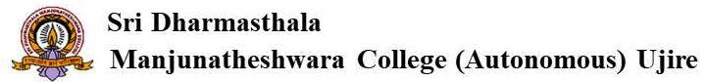
Alumni Committee - Annual Alumni Meet & Alumni Interaction
Coordinator: (Shailesh Kumar) Member from Alumni Committee
Vision: To build alumni Bondage, share the knowledge and refresh the memories
Mission:
- To maintain alumni database, guide departments to regularly organize alumni interaction and organize annual alumni meet
- To promote and foster interaction amongst the Alumni and the faculty members of the SDM College and associate in the developmental activities of the College
- To connect the existing alumnus with the college and bridge the gap of communication between alumnus and students and to promote exchange of academic and corporate experience with the students.
- To mentor and channelize the efforts of the students seeking better opportunities to learn and grow.
- To work with college to suggest new technologies and improvements that shall benchmark industrial expectations.
Methodology
- Planning meeting in the first week of commencement of odd semester
- Identify student coordinators in the first week of commencement of odd semester and Orientation program for student coordinators in the second week of commencement of odd semester
- 2nd Week: Collecting details of prominent alumni from each department (at least two from each department in each semester)
- Last week of every month: Collecting information from all departments regarding alumni interactions organized.
- First week of January: Holding meeting of executive members of alumni association
- First week of March: Preliminary meeting to organize Annual Alumni Meet(scheduled on 1st May)
- Last week of March: Inviting executive committee members to plan Annual Alumni Meet: Guest fixation, scheduling of events, preparing budget, invitation printing, distribution of invitation via mail, email and whatsapp messages.
- 1st May: Assisting Alumni Association ion the conduct of Annual Alumni Meet
Reporting
- Staff coordinator shall display annual plan of action
- Profile of prominent alumni shall be displayed every Monday and the displayed file shall be preserved
- Conducting monthly meeting and recording meeting minutes
- Activity details shall be uploaded in EEPRMS

