PUBLISHED IN DECEMBER 2018
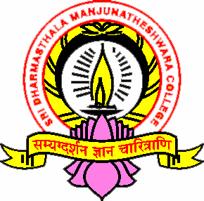
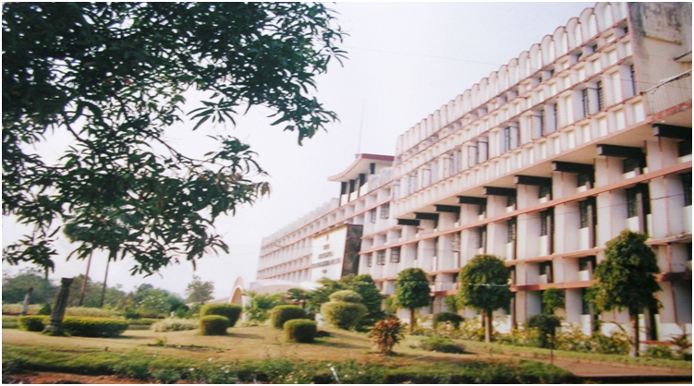
SDM PROFESSIONAL ETHICS
AND
POLICIES
HAND BOOK
IQAC SDMC UJIRE

SRI DHARMASTHALA MANJUNATHESHWARA COLLEGE (AUTONOMOUS), UJIRE-574240

PUBLISHED IN DECEMBER 2018

